**PROJECT REPORT**

**On**

**ONLINE EXAMINATION**



**Bachelor of Technology**

**In**

**Computer Science & Engineering**

**Chandigarh Group of Colleges, Mohali**

Submitted To: Submitted By:

Mr. Simar Preet Singh Vinay Kumar -1802899

Yash Malhotra- 1802261

CSE-E2

Department of CSE CEC,LANDRAN

**INTRODUCTION**

Today Online Examination System has become the fastest growing examination method because of its speed and accuracy.Online Examination is a simple web based application for all the exams which are conducted in country.

This particular project is designed to provide a user interface that asks multiple-choice questions and takes inputs from users as the answers and then, finally evaluates all the questions and gives back the output as the individuals result. It makes an examination to be easily happen and calculate the result of the students.This types of online examination is widely used in top exams which held every year in our country such as GATE,AMCAT,CAT,GRE etc. The project contains various modules such as Question on the top,3-5 options in a particular Question,the back and Next option and at the end it calculate the marks of the student which he or she has obtained.It also need less manpower to conduct and execute the examination.

**FEATURES OF ONLINE EXAMINATION**

* Easy to use and Powerful.
* Automatic Reporting.
* Easy and Advanced Scoring with Multiple Dimensions.
* Both Assess and Collect Data.
* Advanced Time Management.
* Multi Language.
* Several Question Types.
* Question and Answer Accuracy.

**TECHNOLOGY USED**

* Operating System 64 Bit(Windows,Mac,Linux etc).
* Core Java-It includes the Java classes and objects,Interfaces,abstract classes,Multi -Threading etc.
* Java Awt: It is the java GUI package,which includes all the classes need to build a Graphical User Interface.
* Apache Server-The project run on Apache Server.
* Java Swing-Java Swing is a lightweight Java graphical user interface(GUI) widget toolkit that includes a rich of widgets.It is part of the Java Foundation Classes and includes several packages for developing rich desktop applications in Java.
* Java JFrame- The javax.swing.JFrame class is a type of container which inherits the java.awt.Frame class.JFrame works like the main window where components like labels,buttons,text fields are added to create a GUI.

**OBJECTIVE OF THIS PROJECT**

* To provide an Interface through which student can appear for examination online for objective as well as subjective type question.
* The Question will display which entered by the faculty or concerned person.
* Reduce the Cost of Printing of Papers.
* To save the time of student as well as of the conducting authority.
* Objective question will checked automatically by the system from the database.
* To make individuals use to the technology and online Examination.
* To improve the accuracy of checking of the Examination Papers.

**ADVANTAGES OF ONLINE EXAMINATION**

1. ****It saves paper.****  
   You never have to print an exam for your students and hand them out. Saves paper. Saves trees. Everybody happy.
2. ****It saves time.****   
   You can setup an exam in such a way that it will auto-grade itself. If you only use multiple choice questions you never have to check an exam again. The online exam system will take care of that hassle. Completely automated.
3. ****It saves you money.****  
   You don't need to buy any paper. Sending an email is free. On top of that you save on the logistics: your students don't have to assemble in classroom to take the exam. They can do it within a given time frame from their own device. You don't have to rent a classroom. You don't have to hire someone to check the students taking the exam.
4. ****It saves the student money.****  
   Students don't have to travel to a specific location to conduct the exam. So even for students from remote area's it's possible to take the exam.
5. ****It's more secure.****You can make a big [question bank](https://www.onlineexambuilder.com/features/what-is-a-question-bank/item12524) with a lot of questions. Every student gets a random selection from that question bank. So it's of little use to share the questions among the exam takers to give them a head start.

**PROJECT DESIGN PHASE**

* Feasibility Study.
* User Requirements.
* Analysis.
* System Design.
* Program Design.
* Coding.
* Testing.
* Operation.

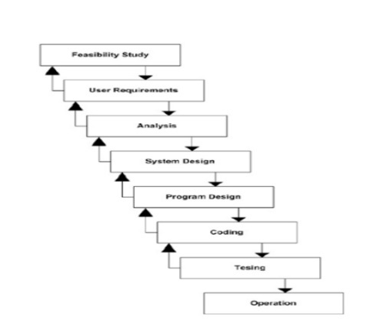

* Feasibility study involves how feasible the solution is to a problem and it satisfies the user requirements or not.
* The next phase of the project is to analyse the project structure, advantages and disadvantages.
* System Design denotes the design that our project is having.
* Coding is the most important part of this project as the working of the project depends upon the coding.
* Before showing or publishing this for commercial use one must test the project whether it is working efficiently or not.If there is any bug reported in need to be resolve.
* The last phase of the project includes the Operations which can be performed on this project. Some of the operations such as selecting,back,next, submit etc.

**SOURCE CODE WITH SCREENSHOTS:**

import java.awt.*;

import java.awt.event.*;

import javax.swing.*;

public class OnlineTest extends JFrame implements ActionListner {

JLabel l;

JRadioButton jb[] = new JRadioButton[5];

JButton b1, b2;

ButtonGroup bg;

int count = 0, current = 0, x = 1, y = 1, now = 0;

int m[] = new int[10];

OnlineTest(String s) {

super(s);

l = new JLabel();

add(l);

bg = new ButtonGroup();

for (int i = 0; i < 5; i++) {

jb[i] = new JRadioButton();

add(jb[i]);

bg.add(jb[i]);

}

b1 = new JButton("Next");

b2 = new JButton("Bookmark");

b1.addActionListener((ActionListener) this);

b2.addActionListener((ActionListener) this);

add(b1);

add(b2);

set();

l.setBounds(30, 40, 450, 20);

jb[0].setBounds(50, 80, 100, 20);

jb[1].setBounds(50, 110, 100, 20);

jb[2].setBounds(50, 140, 100, 20);

jb[3].setBounds(50, 170, 100, 20);

b1.setBounds(100, 240, 100, 30);

b2.setBounds(270, 240, 100, 30);

setDefaultCloseOperation(JFrame.EXIT_ON_CLOSE);

setLayout(null);

setLocation(250, 100);

setVisible(true);

setSize(600, 350);

}

public void actionPerformed(ActionEvent e) {

if (e.getSource() == b1) {

if (check())

count = count + 1;

current++;

set();

if (current == 9) {

b1.setEnabled(false);

b2.setText("Result");

}

}

if (e.getActionCommand().equals("Bookmark")) {

JButton bk = new JButton("Bookmark" + x);

bk.setBounds(480, 20 + 30 * x, 100, 30);

add(bk);

bk.addActionListener((ActionListener) this);

m[x] = current;

x++;

current++;

set();

if (current == 9)

b2.setText("Result");

setVisible(false);

setVisible(true);

}

for (int i = 0, y = 1; i < x; i++, y++) {

if (e.getActionCommand().equals("Bookmark" + y)) {

if (check())

count = count + 1;

now = current;

current = m[y];

set();

((JButton) e.getSource()).setEnabled(false);

current = now;

}

}

if (e.getActionCommand().equals("Result")) {

if (check())

count = count + 1;

current++;

JOptionPane.showMessageDialog(this, "correct ans=" + count);

System.exit(0);

}

}

void set() {

jb[4].setSelected(true);

if (current == 0) {

l.setText("Que1: Which one among these is not a primitive datatype?");

jb[0].setText("int");

jb[1].setText("Float");

jb[2].setText("boolean");

jb[3].setText("char");

}

if (current == 1) {

l.setText("Que2: Which class is available to all the class automatically?");

jb[0].setText("Swing");

jb[1].setText("Applet");

jb[2].setText("Object");

jb[3].setText("ActionEvent");

}

if (current == 2) {

l.setText("Que3: Which package is directly available to our class without importing it?");

jb[0].setText("swing");

jb[1].setText("applet");

jb[2].setText("net");

jb[3].setText("lang");

}

if (current == 3) {

l.setText("Que4: String class is defined in which package?");

jb[0].setText("lang");

jb[1].setText("Swing");

jb[2].setText("Applet");

jb[3].setText("awt");

}

if (current == 4) {

l.setText("Que5: Which institute is best for java coaching?");

jb[0].setText("Utek");

jb[1].setText("Aptech");

jb[2].setText("SSS IT");

jb[3].setText("jtek");

}

if (current == 5) {

l.setText("Que6: Which one among these is not a keyword?");

jb[0].setText("class");

jb[1].setText("int");

jb[2].setText("get");

jb[3].setText("if");

}

if (current == 6) {

l.setText("Que7: Which one among these is not a class? ");

jb[0].setText("Swing");

jb[1].setText("Actionperformed");

jb[2].setText("ActionEvent");

jb[3].setText("Button");

}

if (current == 7) {

l.setText("Que8: which one among these is not a function of Object class?");

jb[0].setText("toString");

jb[1].setText("finalize");

jb[2].setText("equals");

jb[3].setText("getDocumentBase");

}

if (current == 8) {

l.setText("Que9: which function is not present in Applet class?");

jb[0].setText("init");

jb[1].setText("main");

jb[2].setText("start");

jb[3].setText("destroy");

}

if (current == 9) {

l.setText("Que10: Which one among these is not a valid component?");

jb[0].setText("JButton");

jb[1].setText("JList");

jb[2].setText("JButtonGroup");

jb[3].setText("JTextArea");

}

l.setBounds(30, 40, 450, 20);

for (int i = 0, j = 0; i <= 90; i += 30, j++)

jb[j].setBounds(50, 80 + i, 200, 20);

}

boolean check() {

if (current == 0)

return (jb[1].isSelected());

if (current == 1)

return (jb[2].isSelected());

if (current == 2)

return (jb[3].isSelected());

if (current == 3)

return (jb[0].isSelected());

if (current == 4)

return (jb[2].isSelected());

if (current == 5)

return (jb[2].isSelected());

if (current == 6)

return (jb[1].isSelected());

if (current == 7)

return (jb[3].isSelected());

if (current == 8)

return (jb[1].isSelected());

if (current == 9)

return (jb[2].isSelected());

return false;

}

public static void main(String[] args) {

OnlineTest onlineTest = new OnlineTest("Online Test Of Java");

}

}

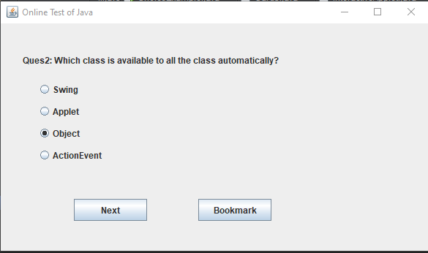

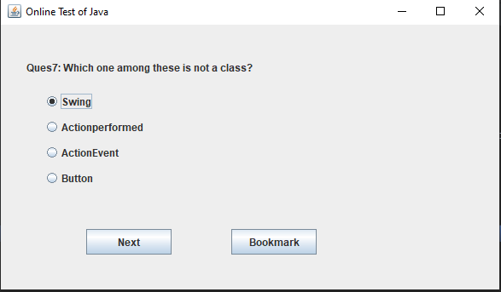

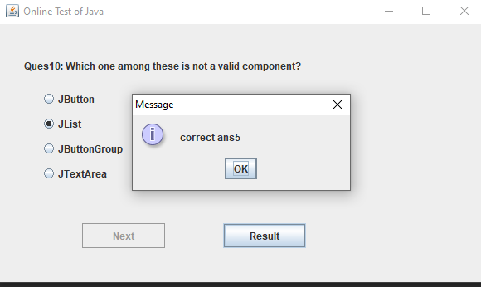

**CONCLUSION:**

Overall this project will provide you platform like which is used now days for online Examination.It provides the best Graphical User Interface and makes it easy to be checked by the answer which are present in the source code of this project. All over it increase the efficiency and Saves our time.

**REFERENCES:**

Programming in Java Nptel lectures for Understanding Java by Prof. Debasais Samanta IIT Kharagpur.

Edureka for Understanding more Concepts.